Ideation Phase
Brainstorm & Idea Prioritization

Date | 30 September 2026
Team ID | SWTID-2026-6249
Project Name | AI FAQ Assistant API
Maximum Marks | 4 Marks

Brainstorm & Idea Prioritization:
For the AI FAQ Assistant API, brainstorming and idea prioritization help the team understand customer needs and identify the most useful solutions. During brainstorming, the team generates ideas such as instant FAQ responses, natural language understanding, multilingual support, accurate search, personalized answers, and easy API integration. These ideas are grouped according to customer problems, expectations, and frustrations identified through the empathy map canvas. The team then prioritizes ideas based on customer value, importance, feasibility, and implementation effort. High-priority features focus on reducing customer waiting time, improving answer accuracy, and providing a simple support
experience. This process helps create a customer-focused and effective AI FAQ Assistant.
Step-1: Team Gathering, Collaboration and Select the Problem Statement
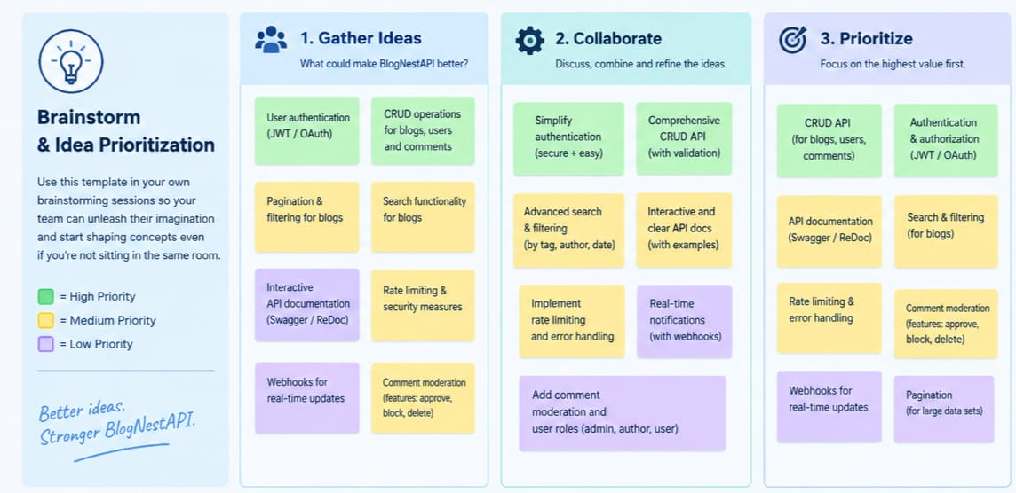

Step-2: Brainstorm, Idea Listing and Grouping
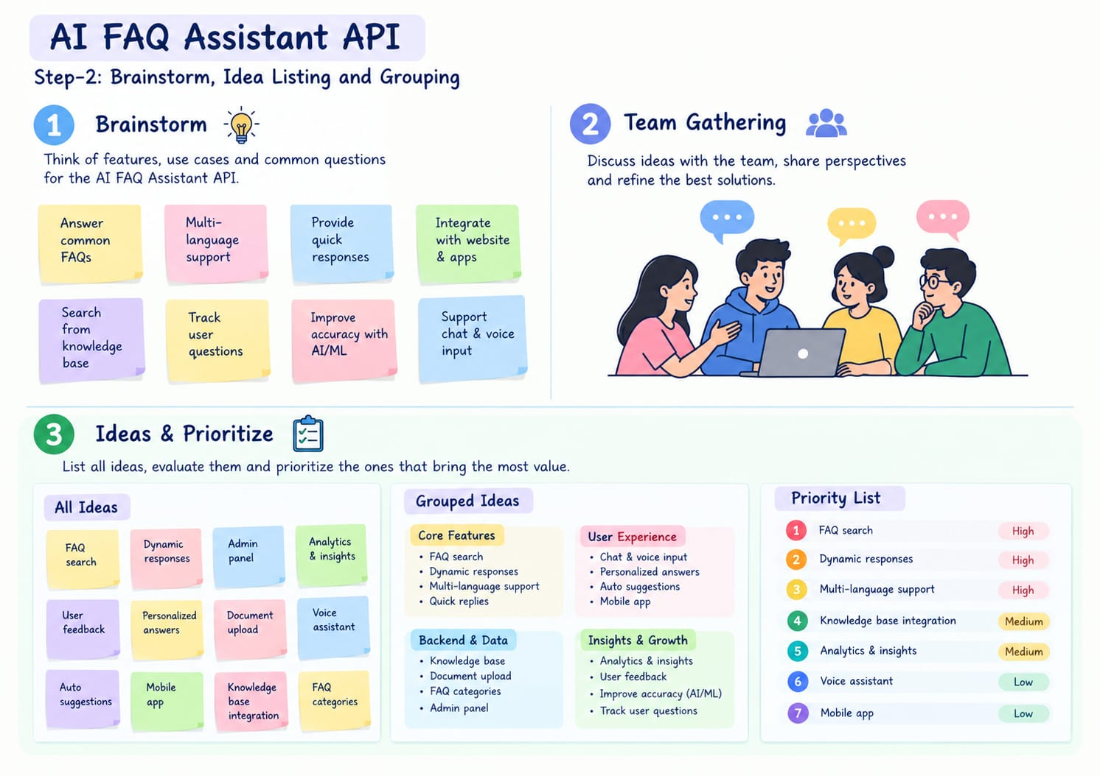

Step-3: Idea Prioritization
